Imaginary Numbers Set
# Source: AI Source: Provided by: [Data Path: Persons Table -> ID Column: 1, Name_En Column: Motasem Essam] -> From: [ChatGPT] on [7/15/2026]
The Imaginary Numbers Set is the set of all numbers that are real multiples of the imaginary unit $i$, where
$$\boxed{i=\sqrt{-1}}$$
Imaginary numbers were introduced to extend the real number system so that equations with no real solutions, such as
$$x^{2}+1=0,$$
can be solved.
Imaginary numbers are fundamental to algebra, complex analysis, electrical engineering, physics, computer science, signal processing, quantum mechanics, and many other branches of mathematics and science.

Definition
# Source: AI Source: Provided by: [Data Path: Persons Table -> ID Column: 1, Name_En Column: Motasem Essam] -> From: [ChatGPT] on [7/15/2026]
An Imaginary Number is any number that can be written in the form
$$\boxed{bi}$$
where
- $b∈R$
- $i=\sqrt{-1}$

Imaginary Unit
# Source: AI Source: Provided by: [Data Path: Persons Table -> ID Column: 1, Name_En Column: Motasem Essam] -> From: [ChatGPT] on [7/15/2026]
The imaginary unit is defined as
$$\boxed{i=\sqrt{-1}}$$
It satisfies the fundamental property
$$\boxed{i^{2}=-1}$$

Symbol
# Source: AI Source: Provided by: [Data Path: Persons Table -> ID Column: 1, Name_En Column: Motasem Essam] -> From: [ChatGPT] on [7/15/2026]
Unlike the Real Numbers Set or Rational Numbers Set, there is no universally accepted standard symbol for the set of imaginary numbers.
It is usually described as
$$\boxed{\left\{ bi∣b∈R \right\}}$$
meaning
"The set of all real multiples of $i$."

Set Notation
# Source: AI Source: Provided by: [Data Path: Persons Table -> ID Column: 1, Name_En Column: Motasem Essam] -> From: [ChatGPT] on [7/15/2026]
Set-Builder Notation
$$\boxed{\left\{ bi∣b∈R \right\}}$$

Description
# Source: AI Source: Provided by: [Data Path: Persons Table -> ID Column: 1, Name_En Column: Motasem Essam] -> From: [ChatGPT] on [7/15/2026]
Every imaginary number is obtained by multiplying a real number by $i$.

Examples
# Source: AI Source: Provided by: [Data Path: Persons Table -> ID Column: 1, Name_En Column: Motasem Essam] -> From: [ChatGPT] on [7/15/2026]
Imaginary numbers include
$$i, 2i, -5i, \frac{1}{2}i, πi, -\sqrt{2} i$$

Non-Examples
# Source: AI Source: Provided by: [Data Path: Persons Table -> ID Column: 1, Name_En Column: Motasem Essam] -> From: [ChatGPT] on [7/15/2026]
The following are not imaginary numbers:
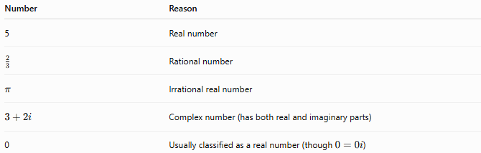
Number | Reason
5 | Real number
$$\frac{2}{3}$$ | Rational number
$$π$$ | Irrational real number
$$3+2i$$ | Complex number (has both real and imaginary parts)
0 | Usually classified as a real number (though $0=0i$)

Characteristics
# Source: AI Source: Provided by: [Data Path: Persons Table -> ID Column: 1, Name_En Column: Motasem Essam] -> From: [ChatGPT] on [7/15/2026]
Imaginary numbers:
- Contain the imaginary unit $i$.
- Have a real coefficient.
- Are not located on the real number line.
- Lie on the imaginary axis of the complex plane.
- Form an infinite set.

Powers of $i$
# Source: AI Source: Provided by: [Data Path: Persons Table -> ID Column: 1, Name_En Column: Motasem Essam] -> From: [ChatGPT] on [7/15/2026]
The powers of $i$repeat every four powers.

Power | Value
$$i^{0}$$ | $$1$$
$$i^{1}$$ | $$i$$
$$i^{2}$$ | $$-1$$
$$i^{3}$$ | $$-i$$
$$i^{4}$$ | $$1$$
$$i^{5}$$ | $$i$$
This repeating pattern continues indefinitely.

Algebraic Properties
# Source: AI Source: Provided by: [Data Path: Persons Table -> ID Column: 1, Name_En Column: Motasem Essam] -> From: [ChatGPT] on [7/15/2026]
Let
$$a=bi,c=di$$
where $b,d∈R$.
Addition
$$bi+di=(b+d)i$$

Subtraction
$$bi-di=(b-d)i$$

Multiplication
$$(bi)(di)=bd i^{2}=-bd$$
The product of two imaginary numbers is a real number.

Division
$$\frac{bi}{di}=\frac{b}{d},d≠0$$
The quotient of two nonzero imaginary numbers is also a real number.

Relationship to Complex Numbers
# Source: AI Source: Provided by: [Data Path: Persons Table -> ID Column: 1, Name_En Column: Motasem Essam] -> From: [ChatGPT] on [7/15/2026]
Every imaginary number is a complex number whose real part is zero.
$$\boxed{bi=0+bi}$$
Thus,
$$\boxed{\{ bi∣b∈R \}⊂C}$$

Complex Plane
# Source: AI Source: Provided by: [Data Path: Persons Table -> ID Column: 1, Name_En Column: Motasem Essam] -> From: [ChatGPT] on [7/15/2026]
Complex numbers are represented on the complex plane.
- Horizontal axis: Real axis
- Vertical axis: Imaginary axis
Imaginary numbers lie entirely on the vertical axis.

Examples
# Source: AI Source: Provided by: [Data Path: Persons Table -> ID Column: 1, Name_En Column: Motasem Essam] -> From: [ChatGPT] on [7/15/2026]
Example 1
Determine whether
$$5i$$
is imaginary.
Yes.

Example 2
Determine whether
$$-\sqrt{3} i$$
is imaginary.
Yes.

Example 3
Determine whether
$$4$$
is imaginary.
No.
It is a real number.

Example 4
Determine whether
$$2+3i$$
is imaginary.
No.
It is a complex number because its real part is not zero.

Example 5
Simplify
$$i^{6}$$
Since
$$i^{4}=1, \\ i^{6}=i^{4}i^{2}=1(-1)=-1.$$

Applications
# Source: AI Source: Provided by: [Data Path: Persons Table -> ID Column: 1, Name_En Column: Motasem Essam] -> From: [ChatGPT] on [7/15/2026]
Imaginary numbers are used in:
- Algebra
- Complex Analysis
- Differential Equations
- Electrical Engineering
- Signal Processing
- Quantum Mechanics
- Control Theory
- Computer Graphics
- Fluid Dynamics
- Electromagnetics

Real-Life Applications
# Source: AI Source: Provided by: [Data Path: Persons Table -> ID Column: 1, Name_En Column: Motasem Essam] -> From: [ChatGPT] on [7/15/2026]
Imaginary numbers appear in:
- Alternating current (AC) circuit analysis
- Wave equations
- Quantum mechanics
- Electrical impedance
- Signal processing
- Control systems
- Fourier analysis
- Vibration analysis
- Electromagnetic fields
- Computer simulations

Common Mistakes
# Source: AI Source: Provided by: [Data Path: Persons Table -> ID Column: 1, Name_En Column: Motasem Essam] -> From: [ChatGPT] on [7/15/2026]
- Thinking imaginary numbers are not numbers.
- Confusing imaginary numbers with complex numbers.
- Forgetting that
$$i^{2}=-1.$$
- Assuming
$$\sqrt{-4}=-2.$$
Instead,
$$\sqrt{-4}=2i.$$
- Believing imaginary numbers lie on the real number line.

Key Points
# Source: AI Source: Provided by: [Data Path: Persons Table -> ID Column: 1, Name_En Column: Motasem Essam] -> From: [ChatGPT] on [7/15/2026]
- Every imaginary number is a real multiple of $i$.
- The defining property is
$$i^{2}=-1.$$
- Imaginary numbers are a subset of the complex numbers.
- They lie on the imaginary axis of the complex plane.
- They extend the real number system to solve equations with no real solutions.

Imaginary Numbers vs. Real Numbers
# Source: AI Source: Provided by: [Data Path: Persons Table -> ID Column: 1, Name_En Column: Motasem Essam] -> From: [ChatGPT] on [7/15/2026]
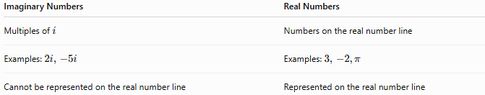
Imaginary Numbers | Real Numbers
Multiples of $i$ | Numbers on the real number line
Examples: $2i, -5i$ | Examples: $3, -2,π$
Cannot be represented on the real number line | Represented on the real number line

Imaginary Numbers vs. Complex Numbers
# Source: AI Source: Provided by: [Data Path: Persons Table -> ID Column: 1, Name_En Column: Motasem Essam] -> From: [ChatGPT] on [7/15/2026]
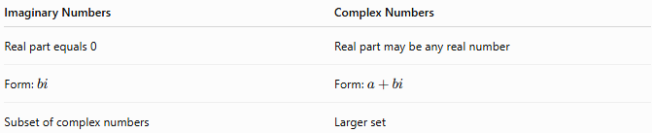
Imaginary Numbers | Complex Numbers
Real part equals 0 | Real part may be any real number
Form: $bi$ | Form: $a+bi$
Subset of complex numbers | Larger set

Imaginary Numbers vs. Real Numbers Set
# Source: AI Source: Provided by: [Data Path: Persons Table -> ID Column: 1, Name_En Column: Motasem Essam] -> From: [ChatGPT] on [7/15/2026]
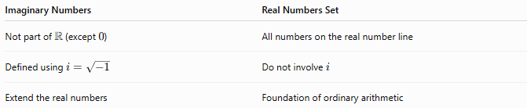
Imaginary Numbers | Real Numbers Set
Not part of $R$(except $0$) | All numbers on the real number line
Defined using $i=\sqrt{-1}$ | Do not involve $i$
Extend the real numbers | Foundation of ordinary arithmetic

Conclusion
# Source: AI Source: Provided by: [Data Path: Persons Table -> ID Column: 1, Name_En Column: Motasem Essam] -> From: [ChatGPT] on [7/15/2026]
The Imaginary Numbers Set consists of all numbers of the form
$$bi,$$
where $b$is a real number and
$$i=\sqrt{-1}.$$
Imaginary numbers extend the real number system, making it possible to solve equations that have no real solutions. They form the imaginary axis of the complex plane and are an essential component of the complex numbers, playing a vital role in modern mathematics, engineering, physics, computer science, and many scientific applications.

